**Week 3(Spring Data JPA with Spring Boot, Hibernate)**

**Exercise : Spring Data JPA - Quick Example**

**File Structure:**

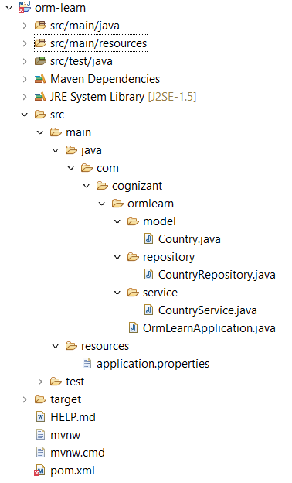

//pom.xml

<project xmlns=*"http://maven.apache.org/POM/4.0.0"*

xmlns:xsi=*"http://www.w3.org/2001/XMLSchema-instance"*

xsi:schemaLocation=*"http://maven.apache.org/POM/4.0.0*

*http://maven.apache.org/xsd/maven-4.0.0.xsd"*>

<modelVersion>4.0.0</modelVersion>

<groupId>com.cognizant</groupId>

<artifactId>orm-learn</artifactId>

<version>0.0.1-SNAPSHOT</version>

<packaging>jar</packaging>

<name>orm-learn</name>

<description>Spring Boot ORM Project</description>

<parent>

<groupId>org.springframework.boot</groupId>

<artifactId>spring-boot-starter-parent</artifactId>

<version>2.7.18</version>

<relativePath/> <!-- lookup parent from repository -->

</parent>

<properties>

<java.version>17</java.version>

</properties>

<dependencies>

<!-- Spring Boot Starter -->

<dependency>

<groupId>org.springframework.boot</groupId>

<artifactId>spring-boot-starter</artifactId>

</dependency>

<!-- Spring Data JPA -->

<dependency>

<groupId>org.springframework.boot</groupId>

<artifactId>spring-boot-starter-data-jpa</artifactId>

</dependency>

<!-- MySQL Connector -->

<dependency>

<groupId>com.mysql</groupId>

<artifactId>mysql-connector-j</artifactId>

<version>8.0.32</version>

</dependency>

<!-- For Testing -->

<dependency>

<groupId>org.springframework.boot</groupId>

<artifactId>spring-boot-starter-test</artifactId>

<scope>test</scope>

</dependency>

</dependencies>

<build>

<plugins>

<!-- Compiler Plugin for Java 17 -->

<plugin>

<groupId>org.apache.maven.plugins</groupId>

<artifactId>maven-compiler-plugin</artifactId>

<version>3.11.0</version>

<configuration>

<source>17</source>

<target>17</target>

</configuration>

</plugin>

</plugins>

</build>

</project>

**//application.properties**

# Logging

logging.level.org.springframework=info

logging.level.com.cognizant=debug

logging.level.org.hibernate.SQL=trace

logging.level.org.hibernate.type.descriptor.sql=trace

# Console log pattern

logging.pattern.console=%d{dd-MM-yy} %d{HH:mm:ss.SSS} %-20.20thread %5p %-25.25logger{25} %25M %4L %m%n

# Database

spring.datasource.driver-class-name=com.mysql.cj.jdbc.Driver

spring.datasource.url=jdbc:mysql://localhost:3306/ormlearn

spring.datasource.username=root

spring.datasource.password=root

# Hibernate

spring.jpa.hibernate.ddl-auto=validate

spring.jpa.properties.hibernate.dialect=org.hibernate.dialect.MySQL5Dialect

**//Country.java**

package com.cognizant.ormlearn.model;

import javax.persistence.*;

@Entity

@Table(name = "country")

public class Country {

@Id

@Column(name = "co_code")

private String code;

@Column(name = "co_name")

private String name;

public String getCode() {

return code;

}

public void setCode(String code) {

this.code = code;

}

public String getName() {

return name;

}

public void setName(String name) {

this.name = name;

}

@Override

public String toString() {

return "Country [code=" + code + ", name=" + name + "]";

}

}

**//CountryRepository.java**

package com.cognizant.ormlearn.repository;

import org.springframework.data.jpa.repository.JpaRepository;

import org.springframework.stereotype.Repository;

import com.cognizant.ormlearn.model.Country;

@Repository

public interface CountryRepository extends JpaRepository<Country, String> {

}

**//CountryService.java**

package com.cognizant.ormlearn.service;

import java.util.List;

import javax.transaction.Transactional;

import org.springframework.beans.factory.annotation.Autowired;

import org.springframework.stereotype.Service;

import com.cognizant.ormlearn.model.Country;

import com.cognizant.ormlearn.repository.CountryRepository;

@Service

public class CountryService {

@Autowired

private CountryRepository countryRepository;

@Transactional

public List<Country> getAllCountries() {

return countryRepository.findAll();

}

}

**//OrmLearnApplication.java**

package com.cognizant.ormlearn;

import java.util.List;

import org.slf4j.Logger;

import org.slf4j.LoggerFactory;

import org.springframework.boot.SpringApplication;

import org.springframework.boot.autoconfigure.SpringBootApplication;

import org.springframework.context.ApplicationContext;

import com.cognizant.ormlearn.model.Country;

import com.cognizant.ormlearn.service.CountryService;

@SpringBootApplication

public class OrmLearnApplication {

private static final Logger LOGGER = LoggerFactory.getLogger(OrmLearnApplication.class);

private static CountryService countryService;

public static void main(String[] args) {

ApplicationContext context = SpringApplication.run(OrmLearnApplication.class, args);

countryService = context.getBean(CountryService.class);

LOGGER.info("Inside main");

testGetAllCountries();

}

private static void testGetAllCountries() {

LOGGER.info("Start");

List<Country> countries = countryService.getAllCountries();

LOGGER.debug("Countries: {}", countries);

LOGGER.info("End");

}

}

**//Mysql**

CREATE DATABASE ormlearn;

USE ormlearn;

CREATE TABLE country (

co_code VARCHAR(2) PRIMARY KEY,

co_name VARCHAR(50)

);

INSERT INTO country VALUES ('IN', 'India'), ('US', 'United States of America');

**Output:**

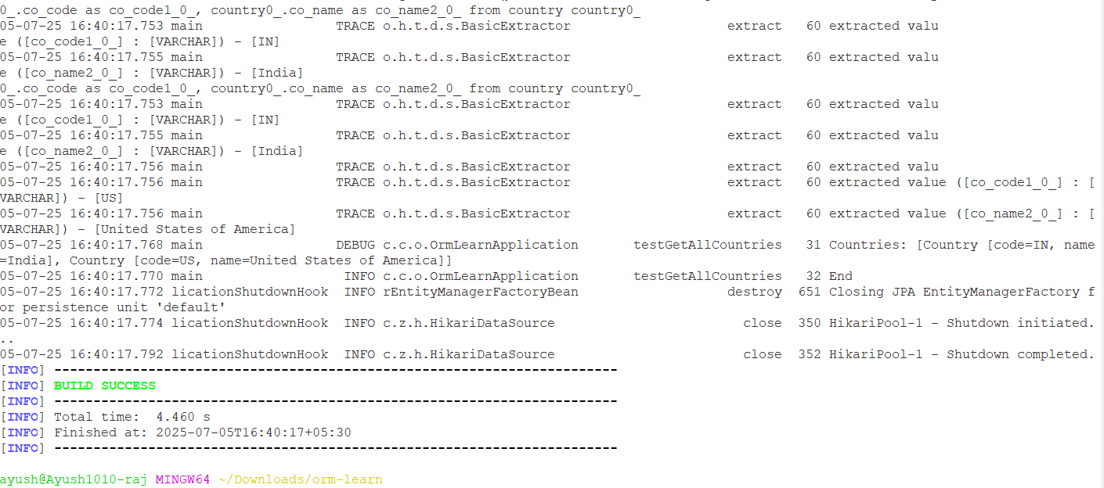

**Exercise: Difference Between JPA, Hibernate, and Spring Data JPA**

**1. JPA (Java Persistence API)**

- JPA is a specification (JSR 338) provided by Java for object-relational mapping (ORM).  
- It defines how Java objects are mapped to database tables.  
- JPA is only an interface and provides annotations like @Entity, @Id, etc.  
- It needs an implementation (e.g., Hibernate) to function.  
- It does not contain any implementation logic.

**2. Hibernate**

- Hibernate is a popular implementation of the JPA specification.  
- It provides the actual ORM logic and supports advanced features such as caching, lazy loading, and criteria queries.  
- Hibernate can be used with or without JPA.  
- It also adds features beyond the JPA specification.

**3. Spring Data JPA**

- Spring Data JPA is a Spring module that builds on top of JPA.  
- It simplifies JPA usage by removing boilerplate code.  
- Provides interfaces like JpaRepository and CrudRepository.  
- Automatically generates query methods like findById, findByName, etc.  
- It is not a JPA implementation but works with one (typically Hibernate).

**Comparison Summary**

|  |  |  |  |
| --- | --- | --- | --- |
| Aspect | JPA | Hibernate | Spring Data JPA |
| Type | Specification (JSR 338) | Implementation (ORM tool) | Spring Framework abstraction |
| Role | Defines persistence rules | Implements JPA + extras | Simplifies JPA usage |
| Dependency | Needs implementation | Self-contained | Depends on Hibernate or others |
| Usage | Used via implementation | Can be used directly | Integrated with Spring Boot |